Daniel DeCarlo

Box # 107

Cairn University School of Business

CIS122 Essentials of Networking

Project # 2

Project objective:

* The objective of this project is to establish a connection to a network using fiber optic cables and switches. Also to create a network connection that won’t be cost heavy and the materials/equipment will be reliable.
* Using fiber optic cables to enhance the speed and the distance of the network.

Equipment used:

|  |  |  |  |
| --- | --- | --- | --- |
| Equipment Description | Vendor | Vendor Item # | Retail price |
| 1-9 Meter Fiber optic cable- OM1 Multimode LC to LC | Show ME Cables  https://www.showmecables.com/by-category/cables/fiber-optic/lc-lc-62-5-125-multimode-duplex-fiber-patch-cable-om1 | SKU  34-507-02M | $9.49 |
| 2x  Cisco Small Business SG350-10MP - Switch - L3 - managed - 8 x 10/100/1000 (PoE+) + 2 x combo Gigabit SFP - desktop - PoE+ (128 W) | Tigerdirect Business  <http://www.tigerdirect.com/applications>  /SearchTools/item-details.asp?EdpNo=1492772 | **Item#:**  40119145  |  **Model#:** SG350-10MP-K9-NA | $382.99  +  $9.99(in shipping)  =  $392.98x2  TOTAL:  $785.96 |
| Raspberry Pi (2x) | Amazon (Canakit)  <https://www.amazon.com/CanaKit-Raspberry-Clear-Power-Supply/dp/B01C6EQNNK/ref=sr_1_2?ie=UTF8&qid=1548968817&sr=8-2&keywords=rasberi+pi> | **MODEL #:** LYSB01C6EQNNK-ELECTRNCS  **ASIN**:  B01C6EQNNK | $49.99  X2  Total:  $99.98 |
| 2x  32 GB SD Card for Raspberry Pi  (optional) | Amazon (Samsung)  https://www.amazon.com/Samsung-MicroSD-Adapter-MB-ME32GA-AM/dp/B06XWN9Q99/ref=pd_bxgy_147_img_2/135-8775144-5573545?_encoding=UTF8&pd_rd_i=B06XWN9Q99&pd_rd_r=4ab40b4f-259c-11e9-9e3c-7da984d71310&pd_rd_w=xHcS6&pd_rd_wg=7nGgt&pf_rd_p=3f9889ac-6c45-46e8-b515-3af650557207&pf_rd_r=K3JWK3K5WTWKKKPGGD8A&psc=1&refRID=K3JWK3K5WTWKKKPGGD8A | MB-ME32GA/AM | $7.99  X2  Total:  $15.98 |
| 2x CAT 5E Ethernet cables (2ft) | Show Me Cables  <https://www.showmecables.com/by-category/cables/cat5e-cat6-cat7/cat5e-ethernet-cables/standard-boot-cat5e-ethernet-patch-cable> | SKU 530-02 BL | $1.10  X2  =  $2.20 |
| HDMI Cables  (for raspberry pi’s and monitors) | Walmart  https://www.walmart.com/ip/RCA-VH12HHR-12-HDMI-to-HDMI-Cable/11959460 | VH12HHR | $8.85  X2  =  $17.70 |
| Total: |  |  | $931.31 |

Detailed list of software and operating platforms used, including version numbers and licensing requirements:

* Raspberry PI software NOOBS (Version 3.00)

License Agreement in the following link:

http://www.wolfram.com/legal/agreements/wolfram-mathematica-raspberry-pi.html))

Network diagram: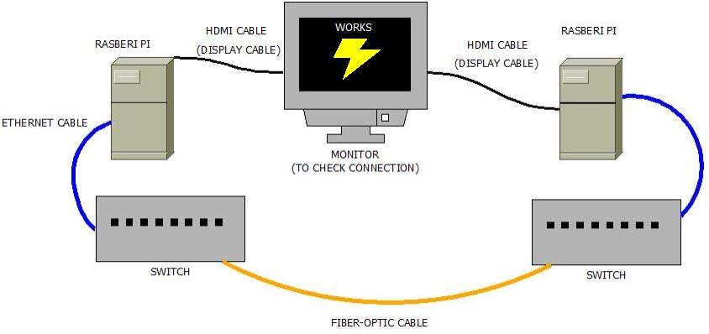

Configurations:

1. Gather all materials listed in the equipment list.
2. Plug in the switches, raspberry Pi’s, and the monitor and make sure they are turned on.
3. Take the fiber optic cable with the LC tip, and remove the rubber tip on one end. Then take the rubber tip off the SFP port on the switch.
4. Plug in the fiber optic cable without the rubber tip and put it into the open SFP port.
5. Repeat steps 3 and 4 for the other switch and other end of the fiber optic cable.
6. Then take the CAT5e Ethernet cables and plug them into the raspberry pi and the switch.
7. Repeat step 6 for the other switch and raspberry pi.
8. When all the cables are plugged in and everything is turned on, open command prompt.
9. Enter ping and the IP Address* of one of the raspberry pi’s. (Use control c to end the loop of sending packets.)
10. If all the packets sent successfully and the amount sent equals the amount received, then the network works and is successful.

*IP address starts with 10. And has 4 sections of numbers total.

An example of an IP address is 10.4.20.47